Search Bar
Header
Welcome to the World of Aurelith
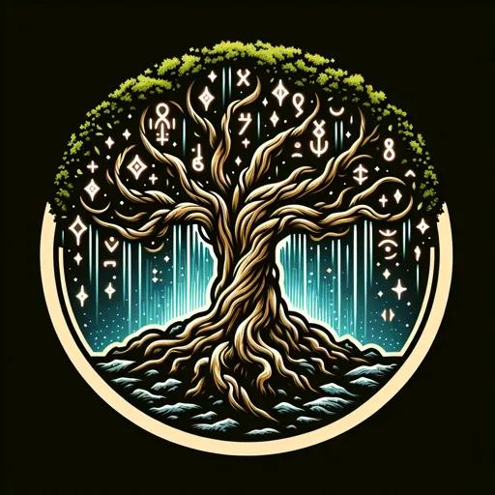

Recent articles
Have a list of the last 5 articles they had visited.
World Map
Categories
Character’s| Location’s | Lore | Creatures

Hero Section

Welcome to the world of Aurelith
[Brief Description about what the World of Aurelith is.]

Footer

About us | Contacts | Credits | Home Page

[Article Title]
[Description of the article

]
in depth Info about the article
if a creature / character tells, how much damage, health, and other possible statuses it might have, do. What faction it is in. if it is hostile, passive, or provoked by something that happens. Any unique traits or abilities. What items it will have on it, the amount of experience you will gain from defeating it. Additional info about certain interactions with certain characters, and other creatures. Any extra info goes here.
If it is a location, it will have what kind of creatures can be in it, what factions have ties to that location and what are the reasons for those ties. The key points in that location. What loot and rewards you can find in there, and the connections it has to other locations around it.
Tips & Tricks
This section will have tips and tricks about the article.

Info about the article
If it is a creature / character, it will have,
Hostile, passive, or provoked.
What faction it is a part of.
Generic basic Stats.
How dangerous it is on a scale based on
X difficulty.
If it is a location
Keypoints in that area.
The connecting locations that have access to that area.
Then what faction the location has ties too.
Lore will most likely not have this.

Article Image
Search Bar
Article Title

Image of concept art of the article or another pov of the article.

Footer

About us | Contacts | Credits | Home Page

About / Contact Us / Credits Page

[Person’s Name] : Description of that person, and what there contributions are, facts about what they like about the World of Aurelith
Phone number
Email

[Person’s Name] : Description of that person, and what there contributions are, facts about what they like about the World of Aurelith
Phone number
Email

Footer

About us | Contacts | Credits | Home Page

Map of Aurelith
Key:

Map of Aurelith
Footer

About us | Contacts | Credits | Home Page

